Group-Work/Tasks on elaboration of DEC Dissemination & Exploitation, Communication strategies
The aim of this exercise in combination with the provided training content is to master you in developing Communication strategies as well as Dissemination and Exploitation Strategies for Research and Innovation Projects such as in Horizon 2020 and for the upcoming Horizon Europe funding programme.
Mastering such a skill will be a great asset for you and your organization in
- Being invited as key partner in H2020/HEU potential projects for developing the DEC strategies in the respective grant applications
- Impressing the funding authorities and their evaluators with the high quality of your DEC strategies in your submitted proposals
- Coaching others to develop winning DEC strategies in their grant applications

You can work on your own if you wish to develop DEC strategies for a specific project that your organization is involved but we suggest you to work in your group as you are seated in your table and apply the following tasks as an experienced DEC manager of the H2020 proposal/project beAWARE.

Task 1: You need to prioritise the identified stakeholders for beAWARE project based on the stakeholders quadrant template or the stakeholders engagement table

Task 2: You need to prepare an impressive communication plan for beAWARE proposal/project. We strongly advise you to use the Communication Plan template provided along with your notes from the training. You are free to modify it accordingly

Task 3: You need to prepare a convincing Dissemination & Exploitation plan for beAWARE proposal/project. Again, we heavily recommend you using the Dissemination and Exploitation template provided along with your notes from the training.

You can download this document with the attached templates from the programme helpdesk page http://bit.ly/IMS-2 as Group_work on elaboration of DEC strategies2.docx

More information about the beAWARE proposal/project follow in the next page. In case you wish some more information, you can visit their website https://beaware-project.eu.

Enhancing decision support and management services in extreme weather climate events

The Challenge
- Extreme weather and climate events, interacting with exposed and vulnerable human and natural systems, can lead to disasters
- Some types of extreme events (e.g. flash floods, fires) have increased
- Response capacity to extreme weather and climate events affecting the security of people and assets
- Current solutions just display inputs to the authorities

beAWARE concept
beAWARE proposes an integrated solution to support forecasting, early warnings, transmission and routing of the emergency data, aggregated analysis of multimodal data and management the coordination between the first responders and the authorities.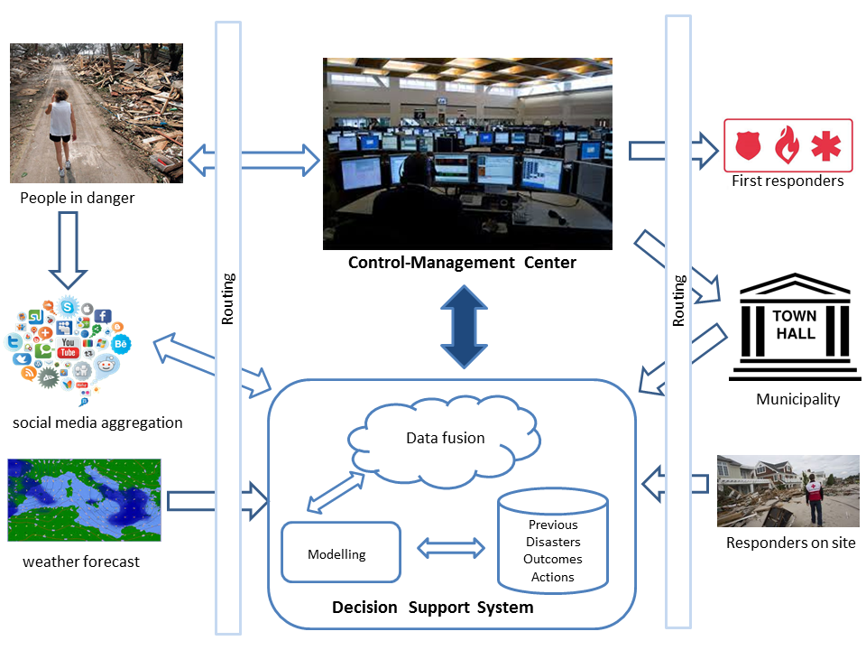

Consortium
- P1: CENTRE FOR RESEARCH AND TECHNOLOGY HELLAS (Greece, Research actor)
- P2: MOTOROLA SOLUTIONS ISRAEL LTD (Israel, Industry)
- P3: UNIVERSIDAD POMPEU FABRA (Spain, Research actor)
- P4: FRAUNHOFER GESELLSCHAFT ZUR FORDERUNG DER ANGEWANDTEN FORSCHUNG EV (Germany, Research actor)
- P5: VALENCIA POLICE (Spain, First responder)
- P6: HELLENIC RESCUE TEAM (Greece, First Responder)
- P7: FINNISH METEOROLOGICAL INSTITUTE (Finland, Data & events provider)
- P8: ALTO ADRIATICO WATER AUTHORITY (Italy, Data & events provider)
- P9: IBM ISRAEL (Israel, industry)
- P10: FREDERIKSSUND-HALSNAES FIRE & RESCUE SERVICE (Denmark, First responder)

Expected Impacts
- New enhanced decision support and early warning services based on aggregated analysis of multimodal data and previous crisis management records
- Shorter reaction time and Higher efficiency of reactions
- Improved coordination of emergency reactions in the field
- Contribution to the European Policy regarding disaster risks and crises management

Key Target Groups
- TG1: Governmental Authorities (Municipalities, Regional Authorities)
- TG2: End Users (first responders)
- TG3: PSAP (emergency call operators) Public Safety Answering Point
- TG4: Technology providers and Industries
- TG5: General Public (citizens)
- TG6: Scientific community
- TG7: Policy Makers and Policy Advisors (Decision makers, civil society organizations)
- TG8: Media

Key events and Journals (Key Target groups)
- European Police Congress, (Industry, LEAs – Law Enforcement Agencies)
- International Conference on Healthcare System Preparedness and Response to Emergencies
- & Disasters IPRED (Health care, disaster relief, emergency practitioners and researchers)
- International Conference on Information Systems for Crisis Response: ISCRAM (Academic researchers and practitioners)
- ESOF – EuroScience OpenForum (Scientists,innovators,policy makers, business people and the general public)
- IAHR Europe Congress “New challenges in hydraulic research and engineering” (Scientists,
- innovators, policy makers, business people)
- International conference on Citizen Observatories for Water Management (Scientists,
- innovators, policy makers, business people)
- International conference on Citizen Sciences (Scientists, innovators, policy makers, business people)
- European Meteorological Society: Annual Meeting :EMS (Researchers)
- ICGTNHM – International Conference on Geospatial Technologies and Natural Hazard (Academic scientists, researchers and research scholars)
- ICNDAHR International Conference on Natural Disasters, Assessing Hazards and Risk (Academic scientists, researchers and research scholars)
- ICGHHAM: International Conference on Geological Hazards, Hazard Assessment and Mitigation (Academic scientists, researchers and research scholars)

Key Results (TRL, IPR)
- R1: Audio and textual recognition module for multilingual speech and written communication analysis in emergency calls (TRL 7, Open Access)
- R2: Machine-to-Machine and Internet-Of-Things platform to aggregate multimodal information from sensor networks, meteorological stations, etc. and social media for decision support and validation purposes and issue early warnings (TRL 7, Open Access)
- R3: Visual context (e.g. indoor/outdoor, city landscape/deserted area) analysis during emergency calls (TRL7, Open Access)
- R4: Policy recommendations regarding disaster risks and crises management (Public)
- R5: Five publications in high-impact journals/conferences (Open Access)
- R6: Development, system integration and support services in key technological areas (speech and text recognition, M2M, IOT, Visual analysis)

Stakeholders Prioritisation Quadrant template

Communication Plan template
What to be communicated | Target Group(s) | Communication objective(s) | Communication Methods | Reach | Phases | By Whom | Intensity level | Communication Milestones
Dissemination & Exploitation Plan
Project Result | Target Group(s) | D&E objective(s) | D&E Methods | Phases | By Whom | Intensity level | D&E Milestones | Expected Impact no

